CONVOLUTIONAL NEURAL NETWORK – HANDS ON
Mnist Dataset

A Convolutional Neural Network (CNN) is a type of Deep Learning algorithm mainly used for image processing and computer vision tasks. CNNs are designed to automatically detect important features in images such as edges, shapes, textures, and objects.

Importing Libraries:
Import all the required libraries for deep learning Numpy,pandas,pydot,tensorflow,sklearn.metrics
Load the Dataset:
The MNIST dataset is available already. We are loading it here and splitting into Training and Test Dataset.
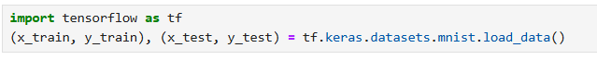
Data Preprocessing :
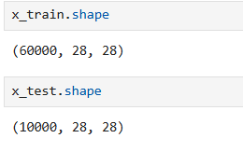
The shape of the training dataset (x_train) is (60000, 28, 28), which means the dataset contains 60,000 images, and each image has a size of 28 × 28 pixels.
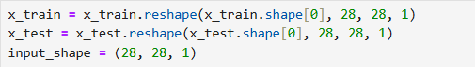
The input should include a channel dimension required for the CNN model. So reshaping to include channels. The additional dimension represents the grayscale channel of the image.
(60000, 28, 28) (60000, 28, 28, 1)
(10000, 28, 28) (10000, 28, 28, 1)
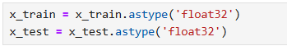
The image pixel values were converted from unsigned 8-bit integers (uint8) to 32-bit floating point numbers (float32) using the astype() function.
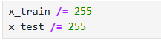
Normalization : This scales the pixel values from 0–255 → 0–1
0 | Black pixel
255 | White pixel
Large values can make training unstable. So we normalize the values.
After dividing by 255:
0 → 0.0
255 → 1.0
Now the pixel values range between 0 and 1.
Normalization improve the efficiency and stability of the neural network during training.
CNN Model Architecture :
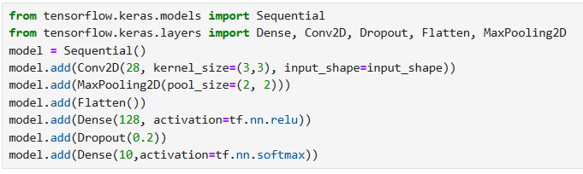
model = Sequential()
The Sequential model allows us to build the neural network layer by layer in sequence.
Each layer’s output becomes the input for the next layer.
Convolution Layer:
model.add(Conv2D(28, kernel_size=(3,3), input_shape=input_shape))
This is the first convolutional layer.
28 Filters, (3,3) Size of the filter , input_shape shape of input image (28 * 28 *1)
Detects features such as edges, patterns, and shapes from the input image.
Max Pooling Layer:
model.add(MaxPooling2D(pool_size=(2, 2)))
The Max Pooling layer reduces the size of the feature map.
Flatten Layer:
model.add(Flatten())
The Flatten layer converts the 2D feature maps into a 1D vector.
Fully Connected Layer :
model.add(Dense(128, activation=tf.nn.relu))
This is a Dense (fully connected) layer.
128 no. of neurons, relu – Activation function
Dropout Layer :
model.add(Dropout(0.2))
The Dropout layer randomly disables 20% of neurons during training.
0.2 20% neurons dropped
Output Layer :
model.add(Dense(10, activation=tf.nn.softmax))
10 No. of output classes, softmax Activation function
Softmax converts outputs into probabilities.
Model Compilation:
The compile() function configures the model for training by defining the optimizer, loss function, and evaluation metric.
Parameter | Description
optimizer='adam' | Algorithm used to update model weights during training
loss='sparse_categorical_crossentropy' | Measures error between predicted and actual labels  Used sparse categorical as labels are integers (0 -9)
metrics=['accuracy'] | Measures percentage of correct predictions
Model Training:
Model learns patterns from Training data
x_train → input images (28×28×1)
y_train → digit labels (0–9)
epochs=10: Model sees entire dataset 10 times
During training:
- Forward propagation
- Loss calculation
- Backpropagation
- Weight updates
Model Evaluation:
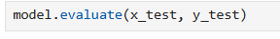
Evaluate performance on unseen test data.
Output Test Loss , Test Accuracy
Purpose:
- Checks generalization ability
- Ensures model is not overfitting
Predictions:
Generate predictions from the trained CNN model.
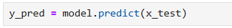
It is predicting the input and Output is probability distribution across 10 classes
[0.01, 0.02, 0.90, ..., 0.00]
Convert Probabilities to Labels:
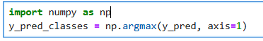
- Picks the index with highest probability
- Converts softmax output → actual digit (0–9)

Confusion Matrix:
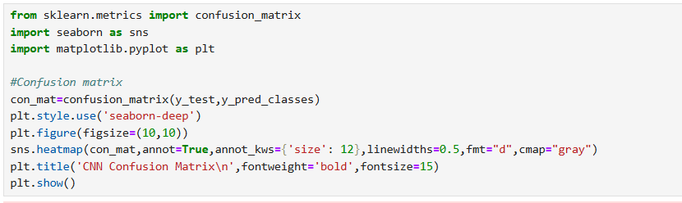
Compare actual vs predicted labels

High Accuracy Model
Strong diagonal dominance indicates excellent performance
Minimal Errors
Misclassifications are very low compared to correct predictions
Pattern-Based Confusion
Errors mostly occur between visually similar digits:
  - 3 and 5
  - 2 and 7
  - 4 and 9
The confusion matrix shows that the CNN model achieves high accuracy with very few misclassifications, mainly between visually similar digits.

